**Unit 5**

**Biomimetics**, also known as biomimicry or bio-inspiration, is an interdisciplinary field that draws inspiration from nature to develop innovative solutions for human challenges. Nature has had billions of years to evolve and refine various mechanisms and systems, and biomimetics aims to leverage this wealth of knowledge for human innovation. Here are some notable examples of biomimetic inventions and their applications:

1. Velcro: Swiss engineer George de Mestral was inspired by the way burdock seeds stuck to his dog's fur during a hunting trip. This led to the invention of Velcro, a widely used fastening system that mimics the hook and loop structure of these seeds.
2. Bullet Trains: The design of Japan's Shinkansen (bullet trains) is inspired by the streamlined shape of the kingfisher's beak. This design reduces noise and energy consumption by minimizing air resistance.
3. Sharkskin-Inspired Materials: Sharkskin has tiny scales with riblets that reduce friction as water flows over it. This concept has been applied to create materials used in swimsuits and even in aircraft to reduce drag and improve efficiency.
4. Lotus-Effect Coatings: The lotus leaf's ability to repel water droplets inspired the development of superhydrophobic coatings. These coatings are used on various surfaces, such as glass and textiles, to make them water-repellent and self-cleaning.
5. Geckos and Adhesive Technology: The gecko's ability to climb walls and ceilings using Van der Waals forces led to the development of gecko-inspired adhesives. These adhesives can be used in various applications, including robotics and medical devices.
6. Termite Mound-Inspired Air Conditioning: The Eastgate Centre in Zimbabwe was inspired by termite mounds, which have a temperature-regulating design. The building uses passive cooling techniques to reduce energy consumption for air conditioning.
7. Bee-Inspired Drones: Researchers have developed drones that mimic the flight patterns of bees, allowing for more agile and efficient flight. This technology has applications in search and rescue missions and agriculture.
8. Biomimetic Prosthetics: Prosthetic limbs have been improved by mimicking the movements and functionality of human limbs. Some prosthetics are designed to mimic the mechanics of natural joints and muscles.
9. Spider Silk Biomaterials: The exceptional strength and elasticity of spider silk have inspired the development of synthetic materials with similar properties. These materials have applications in textiles, medical sutures, and even bulletproof clothing.
10. Bird-Inspired Aircraft Wing Design: Aircraft designers have looked to the structure and shape of bird wings for inspiration. This has led to more efficient wing designs that reduce fuel consumption and increase maneuverability.

**Photosynthesis and photovoltaic cells** are two distinct processes that involve the conversion of sunlight into usable energy, but they occur in different contexts and have different mechanisms. Here's an overview of each:

1. Photosynthesis:
   * Photosynthesis is a biological process that occurs in green plants, algae, and some bacteria.
   * It is essential for the conversion of solar energy into chemical energy in the form of glucose (a sugar) and oxygen.
   * Photosynthesis occurs in the chloroplasts of plant cells, primarily in the leaves.
   * The process can be summarized in two stages: the light-dependent reactions and the light-independent reactions (Calvin cycle).
   * In the light-dependent reactions, solar energy (light) is used to split water molecules and produce oxygen while generating chemical energy in the form of ATP and NADPH.
   * In the Calvin cycle (light-independent reactions), carbon dioxide is fixed and converted into glucose using the energy and reducing power (ATP and NADPH) produced in the light-dependent reactions.
2. Photovoltaic Cells (Solar Cells):
   * Photovoltaic cells, also known as solar cells, are man-made devices used to directly convert sunlight into electricity.
   * These cells are typically made of semiconductor materials, such as silicon, and are widely used in solar panels.
   * When sunlight (photons) strikes the surface of a photovoltaic cell, it excites electrons within the semiconductor, creating an electric current.
   * This electric current can then be used to power electrical devices, charge batteries, or be fed into the electrical grid.
   * Solar cells come in various types, including monocrystalline, polycrystalline, and thin-film, each with different efficiencies and cost considerations.

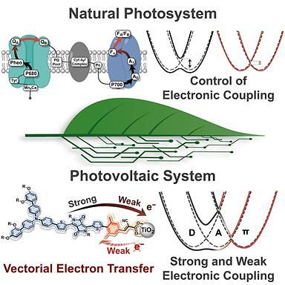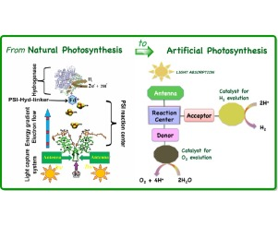

While both photosynthesis and photovoltaic cells involve the conversion of sunlight into energy, they serve different purposes and employ different mechanisms. Photosynthesis is a biological process that converts solar energy into chemical energy for the growth and sustenance of plants, while photovoltaic cells are man-made devices designed to directly generate electrical energy from sunlight for various human applications, including powering homes, businesses, and electronic devices.

**A bionic or artificial leaf** is a technology that aims to mimic the process of photosynthesis found in natural leaves to generate energy, typically in the form of chemical fuel or electricity. This concept has gained significant attention as a potential solution to renewable energy production and carbon dioxide reduction. There are several variations of artificial leaf technologies, but the basic idea is to use sunlight, water, and carbon dioxide to produce energy-rich compounds, such as hydrogen or liquid fuels.

Key features of bionic or artificial leaves include:

1. Light Absorption: Artificial leaves are equipped with light-absorbing materials, such as photovoltaic cells, that capture sunlight and convert it into electrical energy. This energy is then used to power the subsequent chemical reactions.
2. Water Splitting: One of the primary functions of artificial leaves is to split water into its constituent elements, hydrogen and oxygen, through a process called water electrolysis. Hydrogen can be used as a clean fuel source, while oxygen is typically released into the atmosphere.
3. Carbon Dioxide Capture: Some artificial leaf designs aim to capture carbon dioxide from the atmosphere and use it as a raw material for the production of fuels or other chemical compounds. This has the potential to mitigate greenhouse gas emissions.
4. Catalytic Reactions: Artificial leaves incorporate catalysts that facilitate chemical reactions, such as the reduction of carbon dioxide or the production of fuel molecules. These catalysts are essential for efficiently converting the captured energy and reactants into useful products.

The development of artificial leaves is an active area of research, and while promising, there are still significant challenges to overcome, such as improving efficiency, scalability, and cost-effectiveness. If successful, this technology could play a crucial role in sustainable energy production and reducing the carbon footprint of various industries.

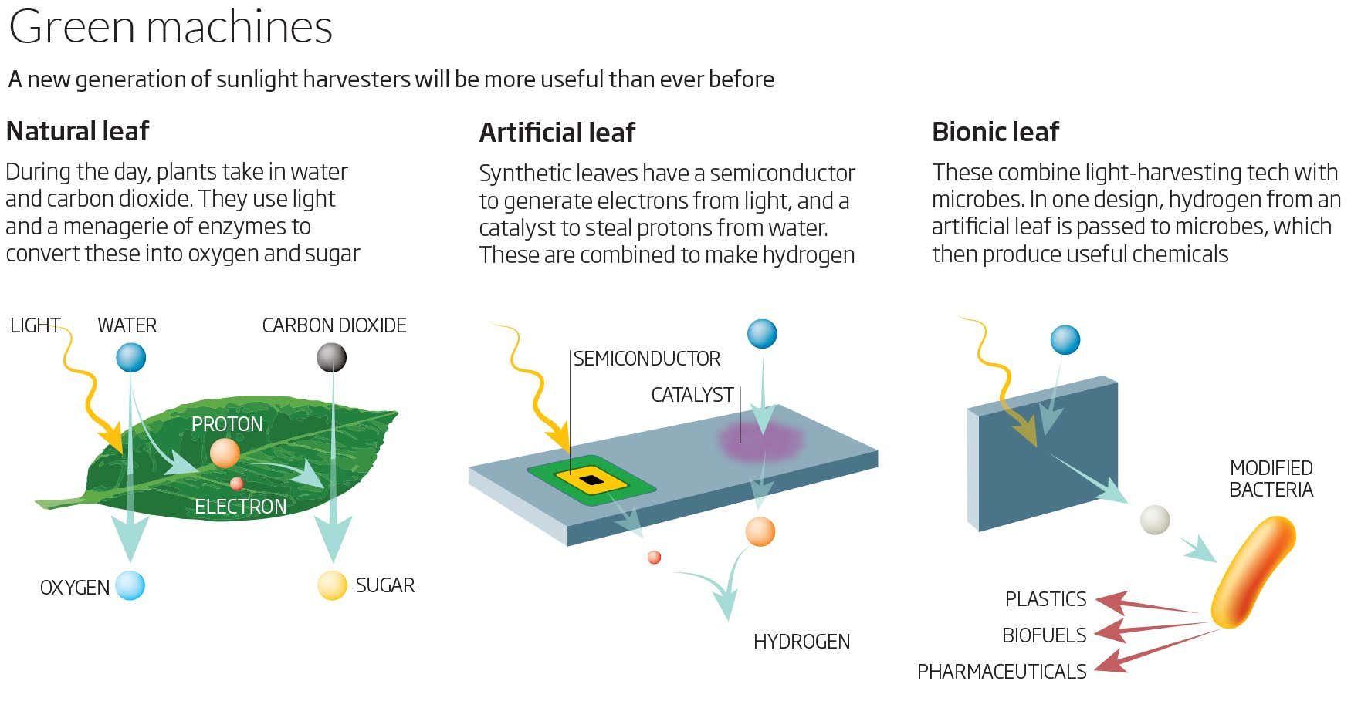

**Bio-ink and 3D bioprinting** are two important technologies in the field of regenerative medicine and tissue engineering. They enable the creation of three-dimensional biological structures, such as tissues and organs, by layering biological materials in a controlled and precise manner. Here's an overview of each:

1. **Bio-ink**:
   * Bio-ink is a crucial component in 3D bioprinting. It is a substance that contains living cells, typically stem cells, and other biologically relevant materials.
   * The bio-ink serves as the "ink" in 3D bioprinting, similar to how traditional 3D printing uses plastic or metal as the printing material.
   * Bio-inks are designed to mimic the extracellular matrix (ECM) found in natural tissues, providing a supportive environment for cells to grow, proliferate, and differentiate.
2. **3D Bioprinting**:
   * 3D bioprinting is a cutting-edge technology that allows the precise deposition of bio-ink to create complex three-dimensional structures with high spatial resolution.
   * It is used to fabricate tissues and organs in a layer-by-layer manner, using computer-aided design (CAD) models to guide the printing process.
   * There are several bioprinting techniques, including inkjet-based, extrusion-based, and laser-assisted bioprinting, each with its advantages and limitations.
   * The ultimate goal of 3D bioprinting is to create functional and transplantable organs and tissues for medical applications, such as organ transplantation, drug testing, and disease modeling.

Benefits and applications of bio-ink and 3D bioprinting include:

* **Tissue Regeneration**: Bio-ink and 3D bioprinting offer the potential to regenerate damaged or lost tissues, making them valuable in the field of regenerative medicine.
* **Personalized Medicine**: This technology can be used to create patient-specific tissues and organs, reducing the risk of rejection in transplant procedures.
* **Drug Testing and Development**: 3D bioprinted tissues can be used for testing the efficacy and safety of new drugs and treatments.
* **Disease Modeling**: Researchers can create disease models by printing tissues with specific pathological conditions, aiding in the study of diseases and the development of therapies.
* **Cosmetic and Aesthetic Surgery**: Bioprinting is explored for applications in cosmetic and reconstructive surgery, including the creation of custom implants and tissues.

However, there are still challenges to overcome, including the need for better bio-ink formulations, vascularization of 3D-printed tissues, and regulatory hurdles before 3D bioprinting can become a routine medical practice. Nonetheless, these technologies hold great promise for the future of medicine and healthcare.

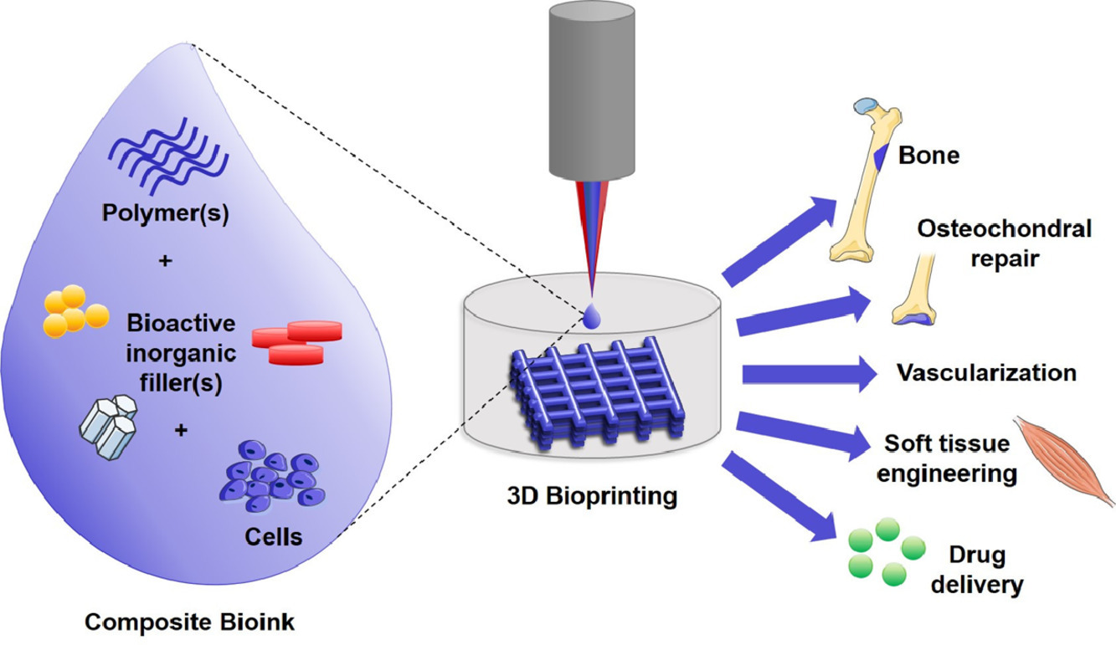

**Cellular automata** (CA) are computational models used to study complex systems and simulate various phenomena, often in the fields of physics, mathematics, computer science, and biology. They consist of a grid of discrete cells, each of which can be in one of several possible states. The grid evolves over discrete time steps according to a set of rules based on the states of neighboring cells. These rules are typically applied uniformly to all cells in the grid.

Key characteristics of cellular automata include:

1. Grid Structure: CA grids can be one-dimensional (1D), two-dimensional (2D), or even higher-dimensional. Each cell has a state, which can change over time.
2. Neighbourhood: CA cells interact with their neighboring cells according to a specified neighborhood configuration. Common configurations include the von Neumann neighborhood (the cell's four adjacent neighbors) and the Moore neighborhood (the cell's eight adjacent neighbors).
3. Rules: The behavior of a CA is determined by a set of rules, which describe how a cell's state changes based on the states of its neighbors. These rules are often expressed in the form of transition functions or tables.
4. Time Steps: CA evolve in discrete time steps, with each step representing a new generation of the grid. The state of each cell is updated simultaneously, making CAs synchronous systems.
5. Boundary Conditions: CA may have different boundary conditions, such as periodic (the grid wraps around at the edges) or fixed (the grid has fixed boundary values).

One of the most famous cellular automata is Conway's Game of Life, which is a 2D CA with simple rules that can lead to complex and interesting patterns and behaviors. In the Game of Life, cells can be either alive or dead, and they evolve based on the states of their eight neighbouring cells.

Cellular automata are used for various purposes, including modeling physical processes, studying emergent phenomena, and exploring computational universality. They have applications in fields like physics, biology, computer science, and even art. Cellular automata have been extensively studied, and they serve as a fundamental concept in the study of complex systems and computational science.

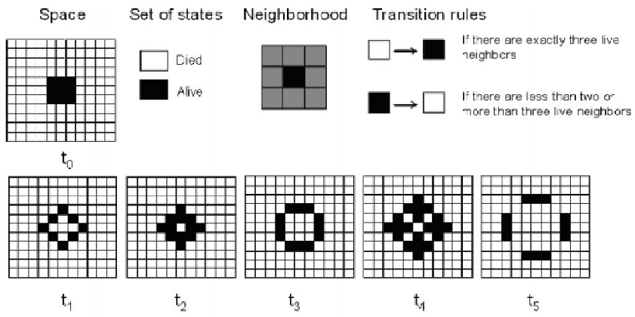

**Artificial tongues and noses** are fascinating examples of sensory technology designed to mimic the human senses of taste and smell. These artificial systems have various applications, ranging from quality control in the food and beverage industry to medical diagnostics and environmental monitoring.

1. **Artificial Tongue**:
   * **Purpose**: An artificial tongue, often referred to as an electronic tongue, is designed to replicate the sense of taste. It consists of sensors that can detect and differentiate between different chemical compounds, mimicking the human taste buds.
   * **Applications**:
     + **Food and Beverage Industry**: Electronic tongues can be used for quality control and flavor profiling of food and beverages. They can detect changes in taste, bitterness, sweetness, and sourness.
     + **Pharmaceuticals**: It's used for taste testing of medications to ensure they are palatable.
     + **Environmental Monitoring**: Detecting and identifying chemical contaminants in water or soil.
   * **Working Principle**: These artificial tongues use an array of chemical sensors that react to various compounds in a solution. The pattern of responses is analyzed to identify and quantify the compounds present.
2. **Artificial Nose**:
   * **Purpose**: An artificial nose, also known as an electronic nose, is designed to replicate the sense of smell. It consists of sensors that can detect and identify various odor molecules, akin to the human olfactory system.
   * **Applications**:
     + **Food Quality Control**: Electronic noses are used in the food industry to detect spoilage, monitor freshness, and assess product quality based on odor.
     + **Medical Diagnosis**: They can assist in disease diagnosis by detecting specific biomarkers in a patient's breath or bodily fluids.
     + **Environmental Monitoring**: Identifying and quantifying volatile organic compounds (VOCs) in the air, which can be associated with pollution or chemical leaks.
   * **Working Principle**: Electronic noses use an array of sensors that react to volatile compounds. The pattern of sensor responses is analyzed to identify and classify odors.

Both artificial tongues and noses rely on machine learning and pattern recognition techniques to interpret the data generated by the sensor arrays. These technologies are continually evolving, becoming more accurate and versatile, and finding applications in a wide range of industries. They offer the advantage of rapid and consistent sensing, making them valuable tools in fields where traditional human sensory evaluation can be subjective and time-consuming.

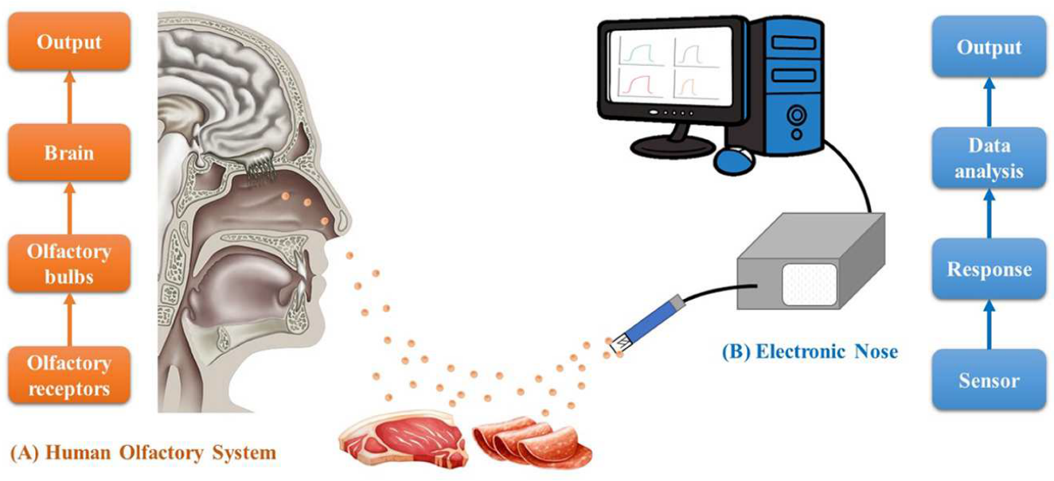

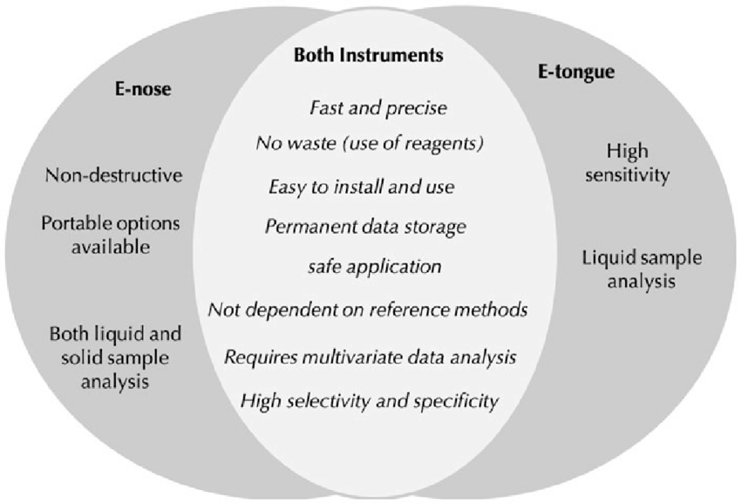

"**Biomimetic echolocation**" refers to a technological approach that draws inspiration from the natural echolocation abilities of certain animals, such as bats and dolphins, to develop artificial systems for a variety of applications. Echolocation is a biological process in which animals emit sound waves and then listen to the echoes of those sound waves as they bounce off objects in their environment. This allows them to perceive their surroundings, locate objects, and navigate in the dark or low-visibility conditions.

Biomimetic echolocation involves creating artificial systems or devices that mimic the principles of natural echolocation. These systems typically include a combination of sensors, transmitters, and receivers to emit sound waves and capture the returning echoes. The data from these systems can be processed to create maps or representations of the environment, detect obstacles, and aid in navigation.

Applications of biomimetic echolocation include:

1. **Assistive Devices for the Visually Impaired**: These systems can help blind or visually impaired individuals navigate their surroundings by providing auditory feedback about obstacles and spatial information.
2. **Autonomous Robotics and Drones**: Biomimetic echolocation can be used in robots and drones to improve their ability to avoid obstacles and navigate in complex, dynamic environments.
3. **Underwater Navigation**: Similar technology can be applied to underwater robots and submersibles to help them navigate and map underwater environments, as dolphins do.
4. **Medical Imaging**: Biomimetic echolocation principles have been explored in medical imaging to improve ultrasound and other imaging technologies.
5. **Wildlife and Environmental Monitoring**: Researchers have used biomimetic echolocation to study and monitor wildlife, particularly bats, to better understand their behavior and ecology.
6. **Search and Rescue**: In disaster scenarios, such as earthquakes or collapsed buildings, biomimetic echolocation technology can be used to locate survivors and navigate through rubble.

The development of biomimetic echolocation systems often involves a combination of hardware (sensors and transmitters), signal processing algorithms, and machine learning techniques to interpret the collected data and make decisions based on it. These systems aim to replicate, to some extent, the incredible spatial awareness that certain animals possess through their natural echolocation abilities.

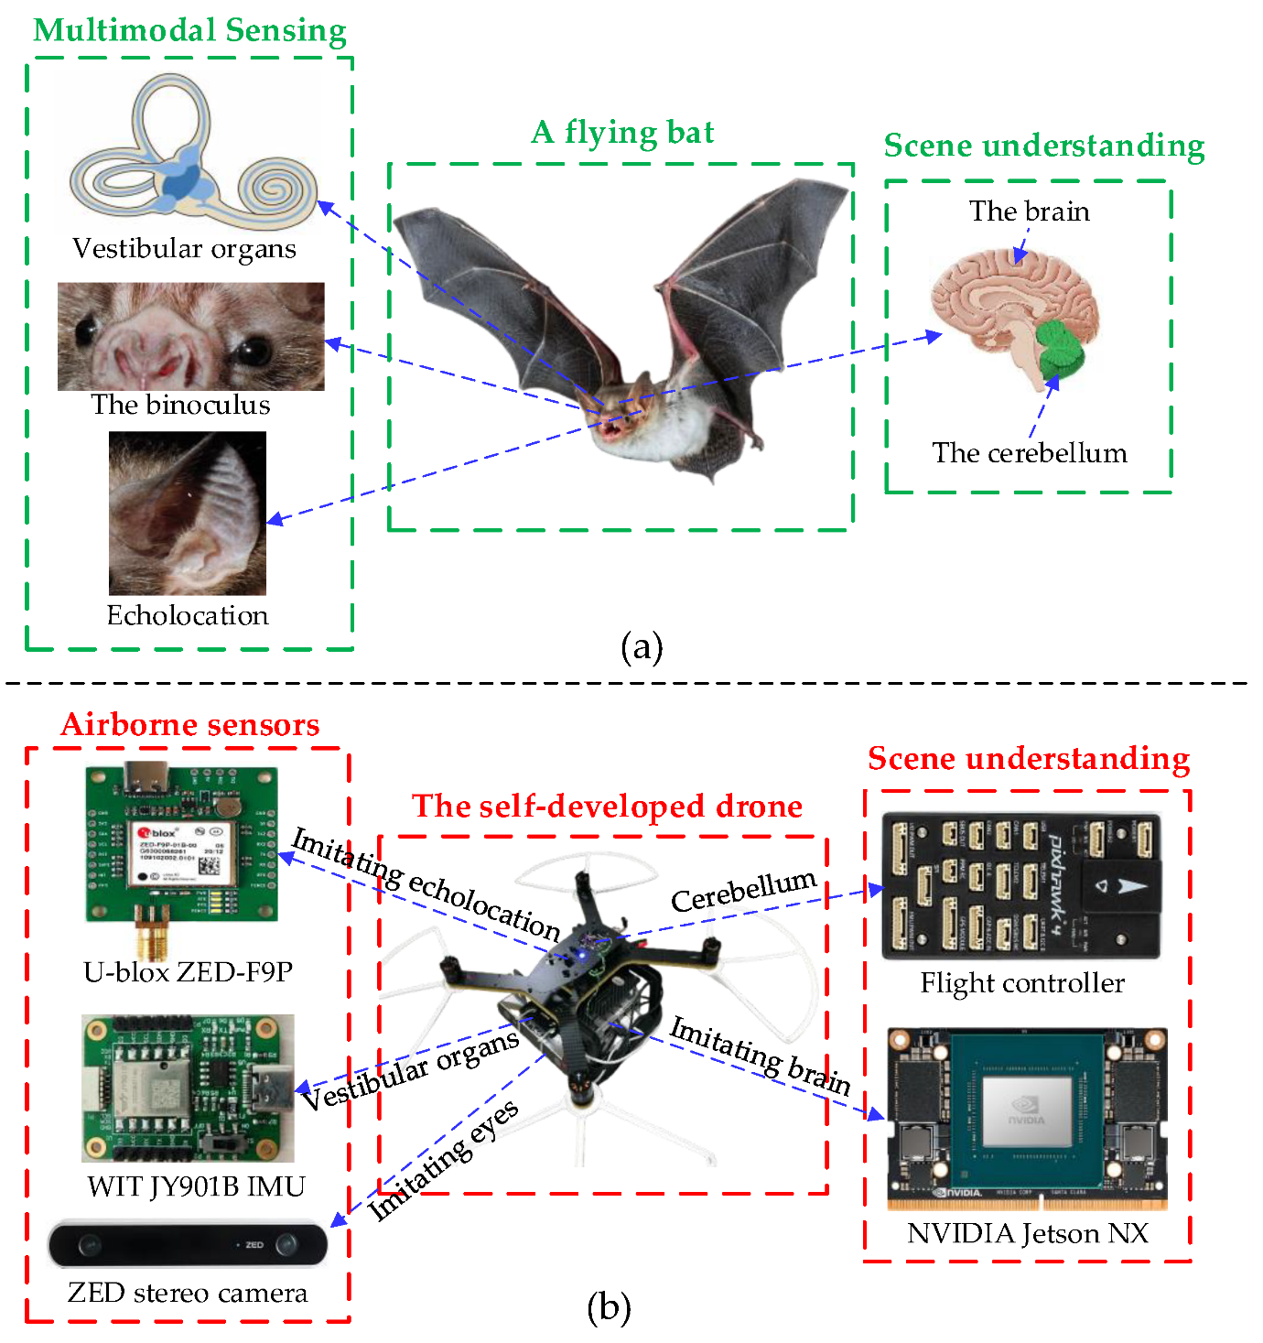

The comparison of the scene-understanding mechanism between bats and robots. (**a**) Bats can perceive the surrounding environment with their vestibular organs, visual perception, echolocation, and spatiotemporal analysis systems. (**b**) Robots can perceive the environment with a set of elaborate biomimetic sensors and a brain-inspired parsing algorithm related to scene understanding.

**Insect foot adaptations for adhesion:** Insects have evolved a wide range of fascinating adaptations for adhesion that have inspired the development of various bioinspired technologies. These adaptations are particularly useful for climbing on various surfaces and navigating complex environments. Some of the key insect foot adaptations for adhesion and their bioinspired applications include:

Microscopic structures: Many insects have microscopic structures on their feet that enable adhesion through van der Waals forces. These structures include tiny hairs, setae, and adhesive pads. Examples include gecko feet and certain beetle species.

Bioinspiration: Engineers have developed synthetic adhesives, such as gecko-inspired adhesive tapes, that mimic the hierarchical structure of these microscopic features. These adhesives can be used in applications like robotics and medical devices.

Wet adhesion: Some insects use wet adhesion, which involves the secretion of adhesive fluids. Examples include tree frogs and certain beetles.

Bioinspiration: Researchers have developed bioinspired adhesives that use wet adhesion principles. These adhesives are being explored for their applications in medical adhesives, underwater adhesives, and industrial bonding.

Claws and spines: Insects like ants and grasshoppers have claws and spines on their feet that help them grip surfaces.

Bioinspiration: Claw-inspired designs have been used in robotics and climbing devices to improve grip and stability on various surfaces.

Suction cups: Some insects, like certain flies and spiders, have evolved suction cups on their feet for adhesion.

Bioinspiration: Engineers have developed suction cup-inspired technologies for applications like robotics, handling delicate objects, and underwater vehicles.

Mechanical interlocking: Insects such as praying mantises use mechanical interlocking mechanisms in their feet to grasp and hold onto surfaces.

Bioinspiration: These interlocking mechanisms have been studied for use in robotic grippers and climbing devices, allowing for improved adhesion and manipulation.

Adhesive secretion and retraction: Certain insects, like ladybugs, can secrete adhesive substances and retract them to control adhesion.

Bioinspiration: Bioinspired technologies are being developed to create controllable adhesives for applications like climbing robots and materials handling.

These insect foot adaptations for adhesion have inspired innovative developments in various fields, from materials science to robotics. By studying and mimicking these adaptations, researchers have created a wide range of bioinspired adhesives and gripping mechanisms that improve adhesion on diverse surfaces and offer solutions to real-world challenges.

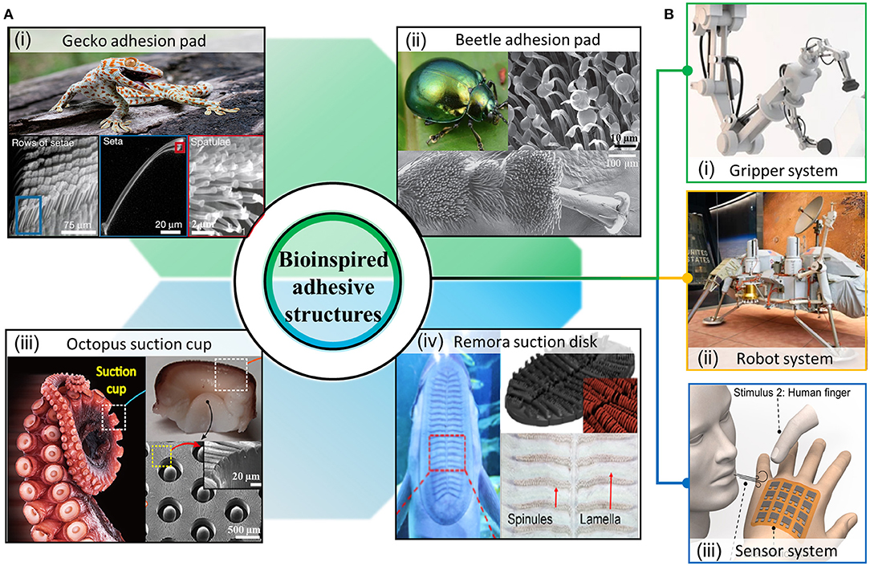

Research schematic of bioinspired adhesive structures for reversible dry and wet adhesion. **(A)** Representative examples of adhesive structures in nature: (i) gecko's toes (ii) beetle's pads (iii) octopus suction cup (iv) remora suction disk. **(B)** Application field of adhesion structure (i) gripper (top), (ii) robot system (middle), (iii) wearable sensor system (bottom)

**Thermal insulation and storage materials inspired by nature**, or bioinspired materials, can offer innovative solutions for various applications. These materials draw inspiration from the strategies and adaptations of organisms in the natural world to achieve effective insulation and temperature regulation. Here are some examples of thermal insulation and storage materials that have been inspired by biological systems:

Fur and Feathers: Animals like polar bears and penguins have evolved dense fur and feathers to insulate their bodies in extreme cold. Engineers have developed synthetic materials with structures mimicking these natural insulators. These materials can be used in clothing and building insulation.

Bioinspired Aerogels: Aerogels are ultra-light, highly porous materials that are excellent insulators. Researchers have developed aerogels inspired by the structure of plants, such as lotus leaves, which have micro and nanostructures that trap air, making them highly insulating.

Phase Change Materials (PCMs): Some animals and plants use phase change materials, like water, to store and release thermal energy. PCM-based materials can be used for thermal storage in buildings and other applications. For instance, researchers have looked to termite mounds for inspiration in developing passive cooling systems using PCM.

Honeycomb Structures: Honeycomb structures found in beehives and the bones of birds are excellent at providing both strength and insulation. These structures have been applied in the design of lightweight, thermally insulating materials for various applications.

Biological Thermal Regulation Mechanisms: Some organisms, such as desert beetles, have evolved ways to collect and radiate heat effectively. Researchers have looked at these natural systems to design materials that can passively regulate temperature in buildings and clothing.

Wood-Inspired Insulation: Wood is a natural insulator. Engineers have sought inspiration from the microstructure of wood to create biomimetic materials for thermal insulation in buildings and other structures.

Fish Scales: The structure of fish scales can be adapted to create materials with excellent heat-insulating properties. These materials can be used in clothing and architectural design.

Cactus-Inspired Cooling: The prickly pear cactus has a unique ability to cool itself by reflecting sunlight. This concept has been used to design roofing materials and paints that help buildings stay cooler in hot climates.

Gecko-Inspired Materials: Geckos have adhesive structures on their feet that allow them to stick to various surfaces. Researchers have used this concept to develop materials that can adhere to and insulate a range of surfaces.

Spider Silk-Inspired Materials: Spider silk is not only strong but also possesses thermal properties that can be mimicked in synthetic materials for thermal insulation and protection.

Bioinspired materials for thermal insulation and storage can offer sustainable and efficient solutions for a wide range of applications, from architecture and clothing to energy-efficient systems. These materials often benefit from the optimized, time-tested designs found in nature, leading to innovative and eco-friendly solutions for modern challenges in temperature regulation and energy efficiency.

**Bees and honeycomb structures** have long been a source of inspiration for various fields, including engineering, architecture, and materials science. The hexagonal structure of honeycombs, in particular, is a remarkable example of nature's efficiency and ingenuity. Here are some ways in which bees and honeycomb structures have inspired human innovation:

Material Efficiency: Honeycomb structures are known for their remarkable material efficiency. Bees construct hexagonal cells with minimal use of wax, which optimizes resource utilization. This has inspired engineers to design lightweight, yet strong, structures in various applications, such as aircraft components and composite materials.

Thermal Regulation: Honeycombs have excellent thermal properties. Bees use these structures to regulate the temperature within their hives. This has influenced the design of building materials and insulation systems that can improve energy efficiency in human architecture.

Aerospace Engineering: The strength-to-weight ratio of honeycomb structures is valuable in aerospace engineering. Honeycomb panels are often used in aircraft and spacecraft design to reduce weight while maintaining structural integrity.

Packaging and Storage: Hexagonal packing structures, similar to honeycombs, have inspired more efficient packaging designs. These designs reduce wasted space and improve the protection of products during transportation and storage.

Flexible Structures: The flexible nature of honeycombs, which can absorb and distribute forces without deformation, has inspired the development of impact-resistant materials for helmets, body armor, and vehicle safety components.

Robotics: The behavior of bees in building honeycombs has inspired swarm robotics and distributed control algorithms. Bee-inspired algorithms are used in fields like logistics, path planning, and even in controlling drone swarms.

Architectural Design: Honeycomb structures have influenced architectural designs that incorporate hexagonal patterns for both aesthetic and functional purposes. These designs often optimize natural lighting, ventilation, and structural integrity.

Urban Planning: The efficiency of bees' spatial organization has been used as a model for urban planning and transportation networks, such as optimizing traffic flow or the design of efficient distribution systems.

Material Manufacturing: Biomimicry of bees has led to advancements in 3D printing technology and the development of cellular materials and structures with various applications, from architectural components to medical implants.

Renewable Energy: Researchers have explored the application of honeycomb-inspired structures in wind turbine blade design, improving the efficiency and reducing the weight of blades.

**ARTIFICIAL INTELLIGENCE**

**Artificial Intelligence** is an attempt to make a computer, a robot, or other piece of technology

‘think’ and process data in the same way as we humans do. AI therefore has to study how the

human brain ‘thinks’, learns, and makes decisions when it tries to solve problems or execute a

task. The aim of AI is to improve technology by adding functionality related to the human acts

of reasoning, learning, and problem-solving. Here are a few practical examples to demonstrate

how AI has penetrated our everyday lives to provide services that we can use extensively to

make our lives easier.

Machines are traditionally known to follow rigid instructions, contemporary machines

are designed to ‘think’ and have the capability to perform tasks by learning. The branch of

science and technology devoted to the creation of machines that learn and think as

intelligently as human beings is known as Artificial Intelligence or AI. According to the father of Artificial Intelligence, John McCarthy, AI is “The science and engineering of making intelligent machines, especially intelligent computer programs”.

The fundamental premise of AI is that it can create machines that can intelligently think in the

same, or similar, way that humans think. It is designed to acquire knowledge or awareness

(cognizance) from its environment, its circumstances, and entities (humans) by learning. AI operates where efforts are made to make a computer, a robot, or a machine think in the

same way a smart human being thinks. AI is thus a replication of how the human brain thinks,

learns, decides, and works, when it tries to solve problems (Bermudez, 2017) resulting in the

creation of an intelligent software system. The purpose of AI is to achieve improvisation in the

functionality of computers by way of functions related to human knowledge, such as problem-

solving, reasoning, and learning.

**Artificial Intelligence (AI)** refers to the simulation of human intelligence in machines, allowing them to perform tasks that typically require human intelligence. AI systems are designed to process and analyze data, make decisions, and learn from experience, similar to how humans do. Here are some key concepts and aspects of artificial intelligence:

1. Machine Learning: Machine learning is a subset of AI that focuses on developing algorithms and models that enable computers to learn from data. Machine learning algorithms can identify patterns, make predictions, and improve their performance over time.
2. Deep Learning: Deep learning is a subfield of machine learning that uses neural networks inspired by the structure and function of the human brain. Deep learning has been instrumental in achieving remarkable results in tasks like image recognition, natural language processing, and more.
3. Natural Language Processing (NLP): NLP is a branch of AI that focuses on the interaction between computers and human language. It enables machines to understand, interpret, and generate human language, making applications like chatbots and language translation possible.
4. Computer Vision: Computer vision involves the development of AI systems that can interpret and understand visual information from the world, such as images and videos. It has applications in object recognition, image analysis, and autonomous vehicles.
5. Robotics: AI plays a crucial role in robotics, enabling robots to perform tasks autonomously or with minimal human intervention. Industrial robots, drones, and autonomous vehicles are examples of AI-driven robotics.
6. Expert Systems: Expert systems are AI programs designed to replicate the decision-making abilities of a human expert in a specific domain. They use rules and knowledge bases to provide advice or make decisions.
7. Reinforcement Learning: Reinforcement learning is a type of machine learning where agents learn to make sequences of decisions to maximize a cumulative reward. It has been used in applications like game playing and autonomous control systems.
8. AI in Healthcare: AI is used in healthcare for tasks such as medical image analysis, drug discovery, and disease prediction. It has the potential to improve diagnostics and patient care.
9. AI in Finance: In the financial industry, AI is used for fraud detection, algorithmic trading, risk assessment, and customer service. It can process large amounts of data to make informed decisions.
10. Ethical and Social Implications: The widespread adoption of AI raises ethical and social concerns, including issues related to bias in AI algorithms, job displacement, and privacy. Efforts are being made to address these challenges and ensure responsible AI development.

AI is a rapidly evolving field with applications across various industries, and its potential for transformative impact is significant.

**Neural networking and biorobotics** are two distinct fields, but they can intersect in various ways to create innovative and biologically inspired robotic systems. Here's an overview of both fields and how they can be related:

1. **Neural Networking (Neural Networks or Artificial Neural Networks)**:
   * Neural networks are computational models inspired by the structure and function of the human brain.
   * They consist of interconnected nodes (artificial neurons) organized in layers, typically an input layer, one or more hidden layers, and an output layer.
   * Neural networks are used for various machine learning tasks, including image recognition, natural language processing, and predictive analytics.
   * Deep learning, a subset of neural networks, uses multiple hidden layers to learn complex patterns and representations from data.
2. **Biorobotics**:
   * Biorobotics is an interdisciplinary field that combines biology and robotics to create robots or robotic systems inspired by biological systems.
   * These systems may mimic the structure and behavior of animals, insects, or humans, and are often designed for specific tasks or research purposes.
   * Biorobots can be used in fields like bio-inspired locomotion, biomimetic materials, and neuroscience research.

Now, here are ways in which neural networking and biorobotics can intersect:

1. **Neuromorphic Robotics**:
   * Neural networks and biorobotics can merge to create robots with biologically inspired control systems. These robots may incorporate neural network models to simulate the behavior of real neural circuits or brain regions.
2. **Biological Control Systems**:
   * Neural networks can be used to develop control algorithms for biorobots. These algorithms can be trained to mimic the neural control systems of animals, allowing robots to exhibit more natural and adaptive behaviors.
3. **Sensorimotor Integration**:
   * Neural networks can be employed in biorobots to integrate sensory information with motor control, making the robots more responsive to their environments and tasks.
4. **Neurological Studies**:
   * Biorobots can be used as tools to study and understand the principles of biological neural systems. Neural networks can simulate or model specific aspects of neural control in these robots for experimental purposes.
5. **Bio-inspired Learning**:
   * Biorobots can incorporate neural networks for learning and adaptation, allowing them to improve their performance over time based on experience, similar to how animals learn and adapt.
6. **Cognitive Robotics**:
   * Integrating neural networks into biorobots can enable the development of more intelligent and cognitive robotic systems that can perform complex tasks and adapt to changing environments.

The combination of neural networking and biorobotics holds promise for creating robots that are not only more capable but also more adaptable and lifelike in their behavior, which can have applications in various fields, including healthcare, search and rescue, and environmental monitoring.